Communications Planning and Strategy Template
Use this editable template to develop and communicate your communications plan.
Current Situation/Background

Provide:
- a background of the organisation
- key trends within the industry (local and global)
- SWOT analysis
- Gaps that speak to the communication problem to be solved with this strategy

Overall Organisational Objectives

What is the overall objective of the organisation? List the most important and also bear in mind those that fall under the period the communications strategy applies to.

- To become one of the top five leading banks in the country and in the continent within three years.

Communications Objectives

What is the objective of the communications strategy?
- To improve brand association as a thought leader in the industry by 25% over a six-month period.

Stakeholder/ Target Audience Segmentation

Outline the key stakeholders and audience segmentation for the organisation and articulate their needs/ behaviour patterns. Doing this will help you to create tailored messages and tactics for each stakeholder group.
Primary target audience – Institutions within the financial industry

 | Institutions within the financial industry
Current behaviour | On the lookout for information and trends, majorly through industry platforms
Level of awareness | Medium
Level of knowledge | High
Method of receiving information | Mainly traditional media and word of mouth
Motivations to engaging with information | Information that has real life implication/ application for the business

Secondary Target Audience – Young and financially savvy Nigerians

 | Institutions within the financial industry
Current behaviour | Digitally savvy and primarily consumes content online
Level of awareness | Medium
Level of knowledge | Low-Medium
Method of receiving information | Digital and social media platforms
Motivations to engaging with information | Practical and easy to assimilate content

Strategy

Here is an example of how you can explain your strategy. Ensure you link the strategy to insights from both the internal and external analysis that was carried out.
Insights from our Research
- An increasing number of young Nigerians are dissatisfied with the traditional mode of banking and financing.
- The future of finance will move in the direction of non-conventional financing channels and mediums, but this is not currently a topic of focus for Nigerian banks.
- Nigerians are hungry for information on how to take advantage of the new trends in finance.
There is no one within the Nigerian and even African financial industry who has taken ownership of the conversations around alternative finance. This is an opportunity to pioneer initiatives in this territory and lead conversations that have an impact.
To meet this need, we are launching AltX – a vibrant platform for content and insights on alternative finance pioneered by Bank X as a sub-brand.
AltX will serve two purposes:
- To provide the industry with data and insights with regards to alternative finance models and trends.
- To provide both finance and non-finance savvy Nigerians with easy-to-understand content on how they can take advantage of alternative finance options
This platform will feature content from university lecturers, industry experts and young finance influencers that will be thought-provoking and trend defining.
AltX will be a sub-brand of Bank X and the name is derived from the combination of alternative and X for easy brand recognition.

Tactics/ Implementation

Provide a visual and detailed explanation of how the tactics will be deployed to implement the strategy. Explain every tactic and link it back to the strategy and the overall objectives to be achieved.

Example
Executive Thought Leadership
Data from communications and engagement research carried out by MCL Group reveals that, people trust other people 90% of the time, but they only trust official corporate messages 33% of the time and people are more likely to engage with corporate brands whose executives use social media.
As we push out content from the AltX platform, it is essential for senior executives in Bank X to also leverage their social media platforms to improve the thought leadership positioning of the bank and contribute to conversations in the public space that are essential under the strategy, as identified by the insights outlined in the previous section.
The social media platform that we will focus on is LinkedIn. LinkedIn has been chosen because it is a leading platform to build thought leadership and to also engage in impactful industry conversations. We will update the LinkedIn of all Bank X’s senior executives and embed essential keywords that speak to alternative finance. Our senior executives will also be featured on tier 1 business publications within and outside Nigeria to amplify the content pushed out for thought leadership purposes.
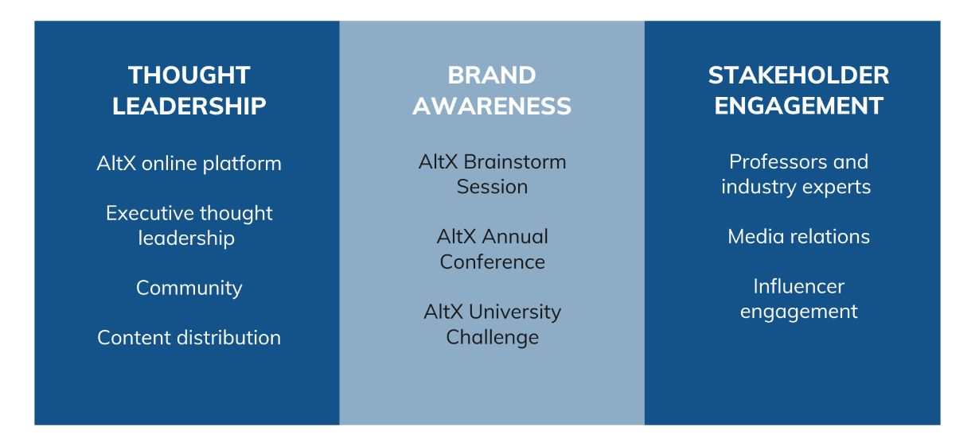

Key Message Per Target Audience

Briefly outline what you want to say to each target audience/ stakeholder previously identified.

Primary Target Audience – AltX is the number one platform for future-forward insights and trends within the industry.

Secondary Target Audience – AltX is where to get simple and useful information and tips about alternative finance.

Communications Mix

List out the communications channels that apply to the tactics to be deployed for the strategy.

TACTICS |  | CHANNELS
Thought Leadership | Owned platform | AltX Website  Search Engine Optimization (SEO)
Thought Leadership | Executive thought leadership | LinkedIn  Tier 1 business publications
Thought Leadership | Content distribution | Social media  Traditional media  Influencers
Event | AltX Brainstorm Session | Website  LinkedIn + Facebook  Digital media ads  Influencers (youth + finance)
Event | AltX Annual Conference | SEO  Business/ finance media and blogs  ATL and BTL advertising

Execution Timeline/ Calendar

Give an overview of the timeline for the execution of the strategy. When will it begin? When will the tactics be implemented?

Each line activity should have a unique colour and the colour should reflect the months in which the tactic till run for. The calendar must align with the strategy and tactics explained in the previous sections.

TACTICS |  | JAN | FEB | MAR | APR | MAY | JUN | JUL | AUG | SEP | OCT | NOV | DEC | JAN 23 | FEB | MAR | APR | MAY | JUN
Thought Leadership | AltX Platform Launch
Thought Leadership | AltX Thought Leadership Content
Thought Leadership | Executive thought leadership
Thought Leadership | Media interviews and features
Brand Awareness | AltX Brainstorm Session
Brand Awareness | AltX Annual Conference
Stakeholder Engagement | Professors and industry experts
Stakeholder Engagement | Media relations
Stakeholder Engagement | Influencer engagement

Evaluation/ KPIs

This is where you outline how the effectiveness of the strategy will be measured. Below is an example of metrics and KPIs you can measure.

Remember to measure metrics that are important for your organisation and what your organisation wants to achieve.

Activity | KPIs | Measurement Tool | Frequency
AltX Thought Leadership Platform | % Website traffic | Backend website analytics | Weekly
AltX Thought Leadership Platform | % Organic shares | Social media analytics | Monthly
AltX Thought Leadership Platform | % Increase in share of voice | Share of Voice measurement tool | Half-yearly
AltX Thought Leadership Platform | Search engine ranking | Google analytics | Monthly
AltX Thought Leadership Platform | % Increase in brand reputation | Survey | Half-yearly
Executive thought leadership | No of post views | LinkedIn analytics | Weekly
Executive thought leadership | % Engagement with content | LinkedIn analytics | Monthly
Executive thought leadership | % Improved knowledge about the CSCS brand | Survey | Half-yearly
Media relations | % Earned media | Media monitoring | Monthly
Media relations | % Accuracy of key messages shared by the media | Media monitoring | Monthly
Media relations | Number of press features | Media monitoring | Weekly
Influencer engagement | % Leads generated for Bank X’s content/ campaign | Social media monitoring tool | Monthly
Influencer engagement | % Increase in conversations about Bank X | Social media monitoring tool | Monthly

