Max Mobile Unveils Its Premium Flagship Smartphone, Ultra-code A.

FOR IMMEDIATE RELEASE

ACCRA, May 19, 2022 – Max Mobile launches the latest addition to its Ultra Smartphone Series, the Ultra-code A, today. Created to meet the needs of the tech-savvy 21st century smartphone user through its blend of functionality and design, the Ultra-code A will be available in the Africa, Asia and select international markets.

The Ultra-code A which combines the best of both worlds of the Ultra and Max Mobile E Series is aimed at giving a sophisticated mobile experience without compromising performance. Key features of the Ultra-code A include an updated software interface with a cleaner colour palette, softer white menus, and an overall nicer-looking aesthetic. Externally, the Ultra-code A has a rich-looking, glass-and-metal-fused design and a water-resistant battery case which delivers power wirelessly.
With its premium look and enhanced security features, the Ultra-code A showcases Max Mobile’s innovative abilities and sustained leadership position in the technology industry.
Fred Otieno, Chief Executive Officer at Max Mobile said, “While Max Mobile is well-known for developing functional smartphones, the Ultra-code A has now shifted us into the realm of design. The Ultra-code A is not just about functionality; it is also about creating a memorable user experience through design.”
For more information about the Ultra-code A and its features, please visit the dedicated landing page - https://www.maxmobile.com/ultra-code-A/.

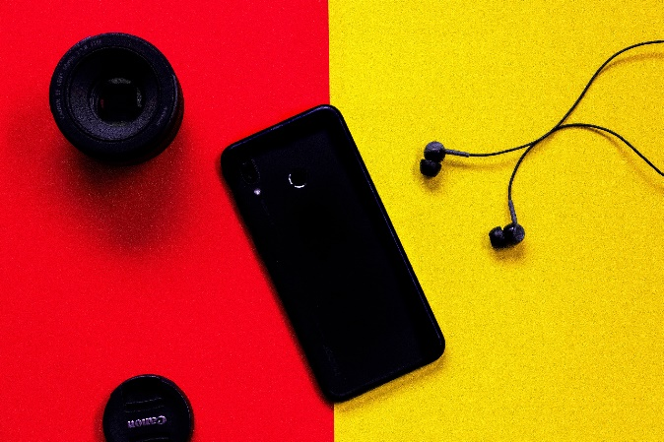

ABOUT MAX MOBILE
Max Mobile is a leading smartphone company headquartered in Gold Coast, Ghana. Starting out as a phone repair business in 1990, Max Mobile has today become the world's largest manufacturer of smartphones with over 60 models sold in 55 countries across the world. With the launch of the Ultra-code A, Max Mobile is sealing its position as a formidable player in the global smartphone industry.

MEDIA CONTACT
Ashley Mensah, Public Relations Officer, Max Mobile
Telephone: +233 4565893
Email: amensah@maxmobileworld.com

